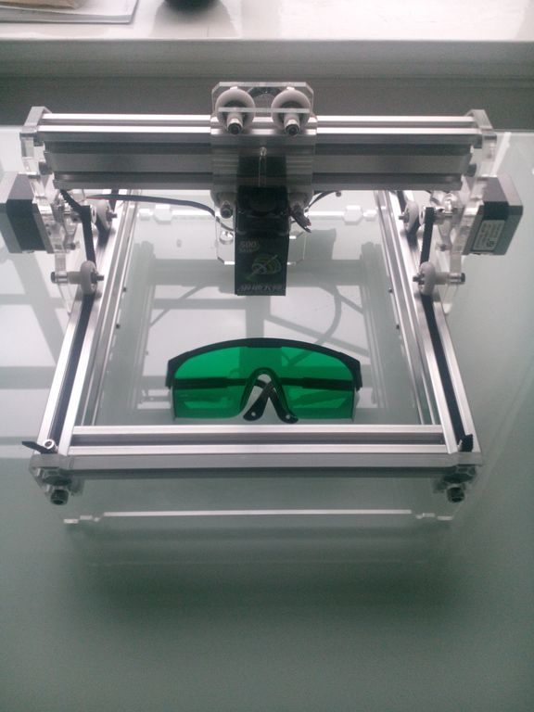
Mini Laser User Guide by Eleven Robots
1. Health & Safety
Like all tools if not used correctly this machine can cause serious injury and damage, please do not ignore these guidelines

  - Never stare directly into the laser beam. Be careful of where the light might reflect
  - Always use the supplied safety glasses when using the laser
  - Laser engraving creates fumes, always use in a well ventilated area free of debris
  - Never engrave the following materials:
Any material containing Chlorine.
Vinyl and PVC (Cintra) will product a corrosive gas – both contain chlorine.
Polycarbonate (PC, Lexan) will produce a black and yellow gas that will make you sick to your
stomach.
Do not attempt to engrave metals, it will reflect the light back into the diode most likely damaging it in the process.
  - If engraving plywood, purchase laser grade ply, the modified glue is not as hazardous when burnt
  - Do not run the machine unattended

2. Machine Interface

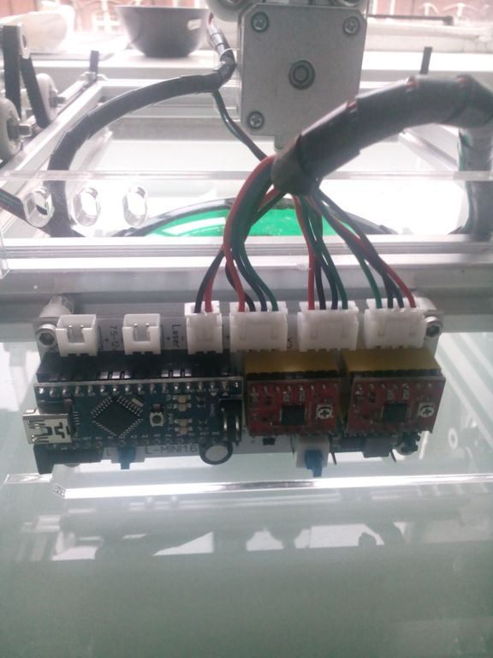
Machine ON/OFF
Low light mode. Turns on the laser with
low power, used to position the laser on the
material before engraving starts.
USB/Power connectors

- Installing the board drivers (Windows only)
For windows XP and up the board drivers should install automatically. The laser engraver is based on an arduino nano board and nano drivers should be installed accordingly. Please see https://www.arduino.cc/en/Guide/Windows#toc4

- Using the Laser Engraver
The general workflow for using the engraver is as follows create image(Inkscape)->create g-code from the image (inkscape plugin)->send the gcode to the engraver (GRBL controller)
Required software:
  - inkscape https://inkscape.org/en/
  - GRBL controller http://zapmaker.org/projects/grbl-controller-3-0/

  - Creating an image and generating the gcode is covered in the following tutorial: https://jtechphotonics.com/?page_id=2012
Note the final step when generating the gcode-
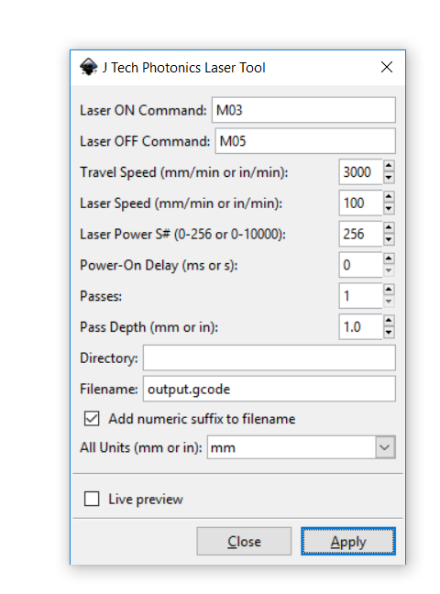
M03/M05- laser on/off
Speed when the laser is off, 200mm
Is an ok default value- but
Experiment is different values
Speed of the engraving. 100mm
is a good starting point
experiment with different values
  - When you have connected your machine via USB open up the device manager and check the COM port
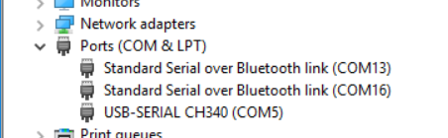
  - Open GRBL controller and open a connection to the COM port
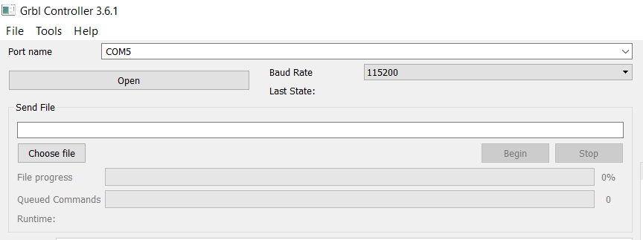
Note the default baud rate of the controller is 115200
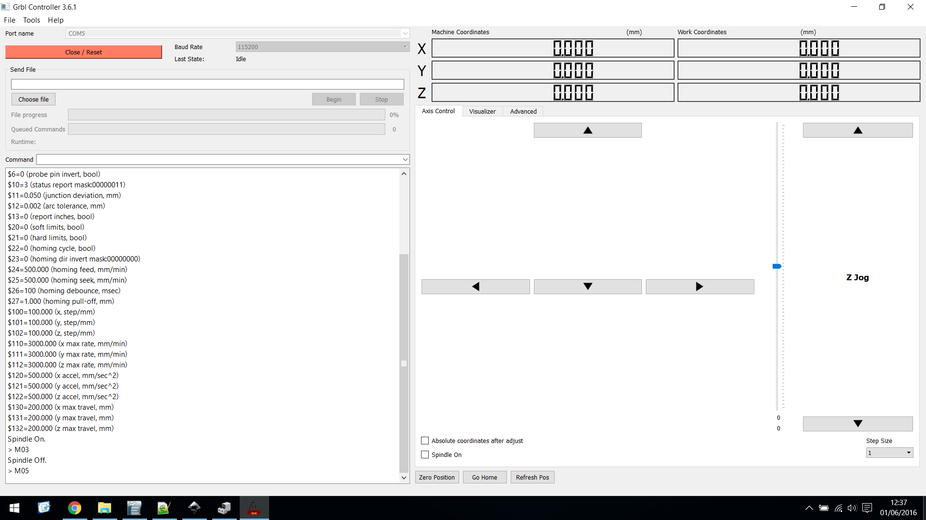
4.6 use the low light button on the controller to turn on the laser, use the arrows to put the laser head where you want the engraving to begin.

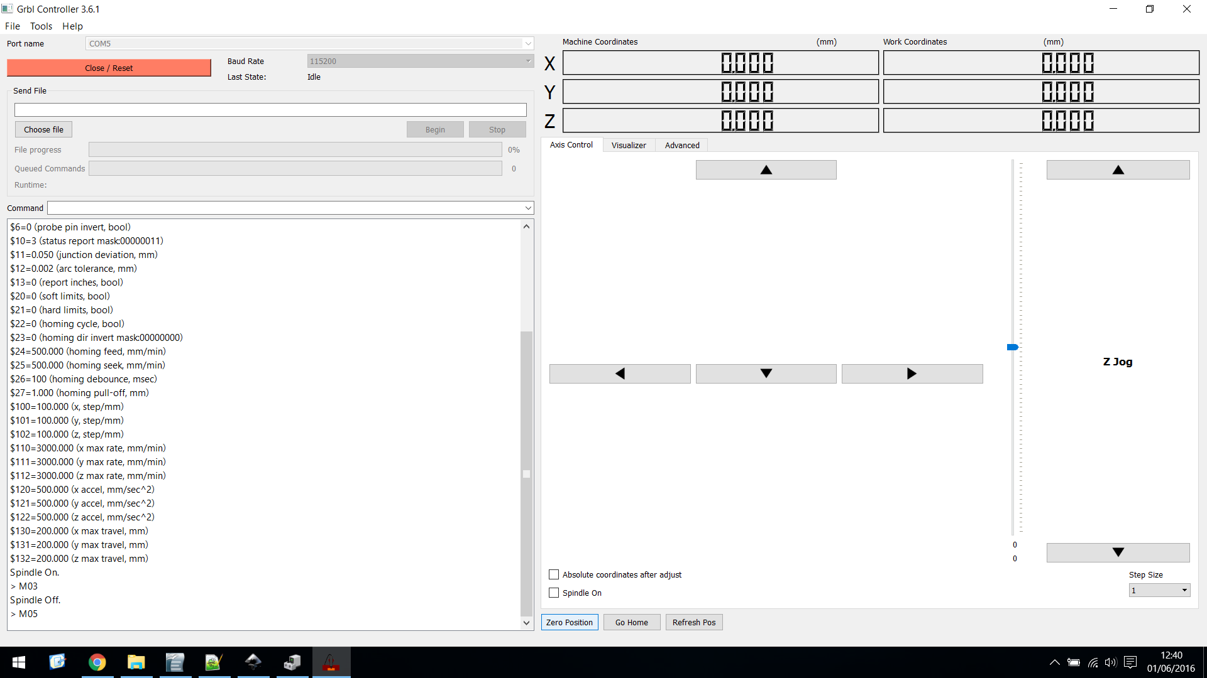
Once the laser head is in the position you want the engraving to start from (usually bottom left), select 'zero position'. This essentially sets the machine position to co-ordinates 0,0. Turn off low power mode.

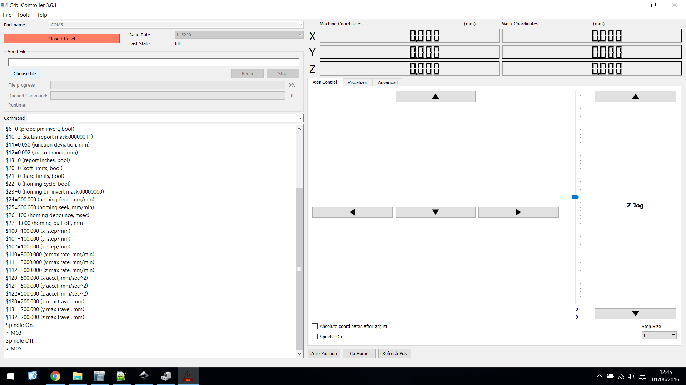
Select the g-code file that was generated from the inkscape plugin

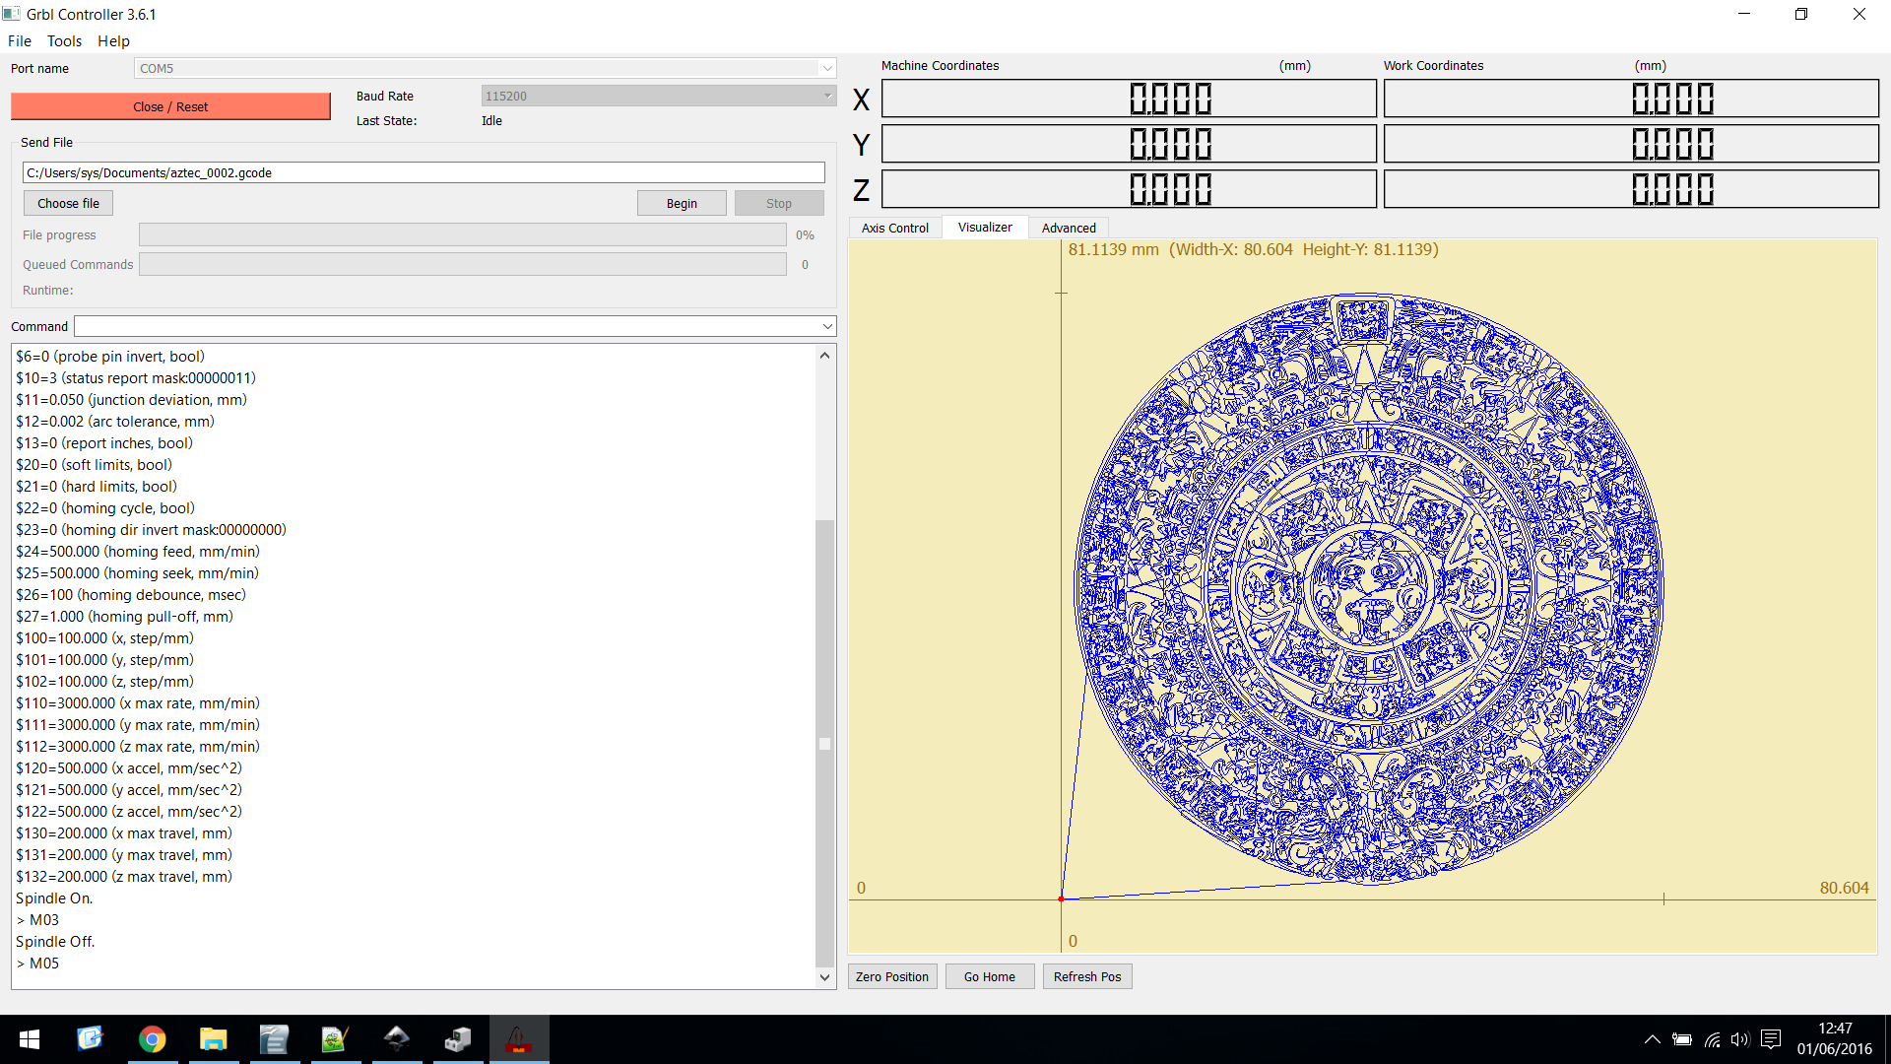
This point represents the 0,0
position of the machine, all
movements are relative to this
point

Use the visualizer to see how the machine will move based on the file that ha been selected. Once you are happy select 'begin' and engraving begins:
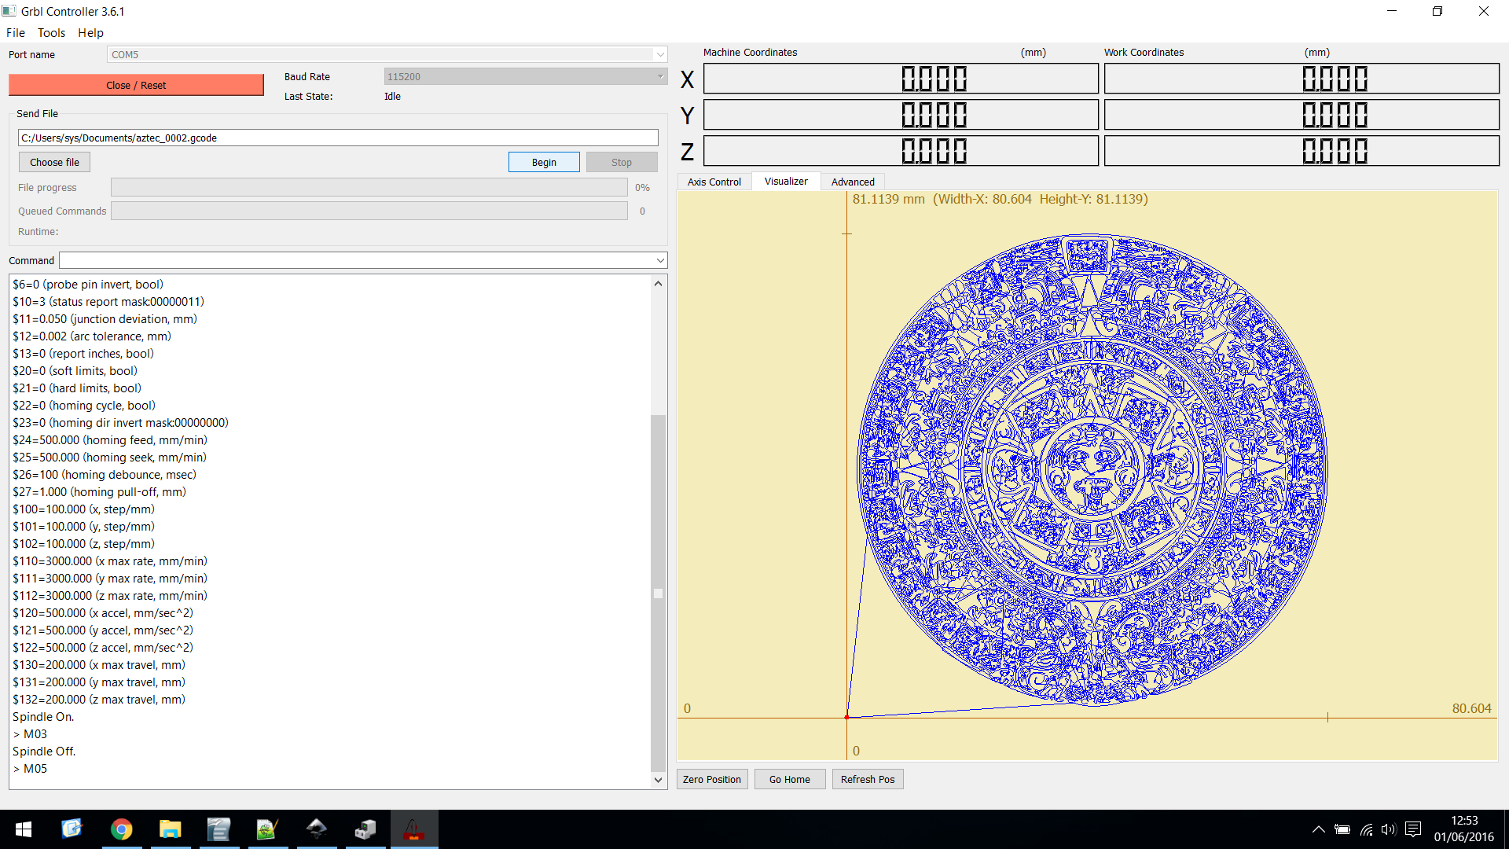

To maintain the laser diode it is recommended you do not engrave longer the 30 minutes continuously.

If you have any questions/ queries please contact:
support@elevenrobots.com

